Organic Chemistry

- Select the best technique for the removal of a drying agent from an organic solvent. (2 points)
(a) simple distillation (b) gravity filtration
(c) fractional distillation (d) vacuum filtration

- List the three processes required for any distillation technique. (3 points)
(i)
(ii)
(iii)

- What precaution must be observed when extracting an acidic solution with sodium bicarbonate? (3 points)

- Name three routes by which chemical substances may enter the body and, for each, a laboratory practice to minimize exposure. (6 points)

- Complete the flow chart below for the separation of the mixture of biphenyl, aspirin and catechol. Draw the structure of the organic compounds in the appropriate box at the end of each step and the required reagent below each line. The acidic compounds will be in their conjugate base form. (6 points)
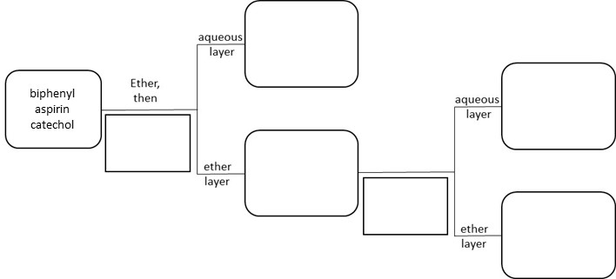

- Ethanol is considered a (2 points)
(a) non-polar solvent (b) polar aprotic solvent
(c) polar protic solvent (d) an ionic solvent

- The purpose of washing an ether solution with a saturated sodium chloride solution is
(2 points)
(a) to remove traces of acid (b) to extract inorganic compounds
(c) to remove unreacted sodium bicarbonate (d) to remove excess water

- Give the product of the following reaction. (3 points)
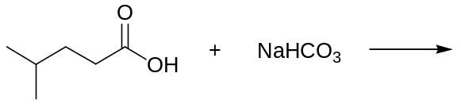

- Defend or refute: If both components of a solution are volatile, stable at their boiling points, and have differing boiling points, they can be separated by fractional distillation. Justify your answer. (3 points)

- The boiling point composition diagram for a binary mixture of benzene and isopropanol is shown below:
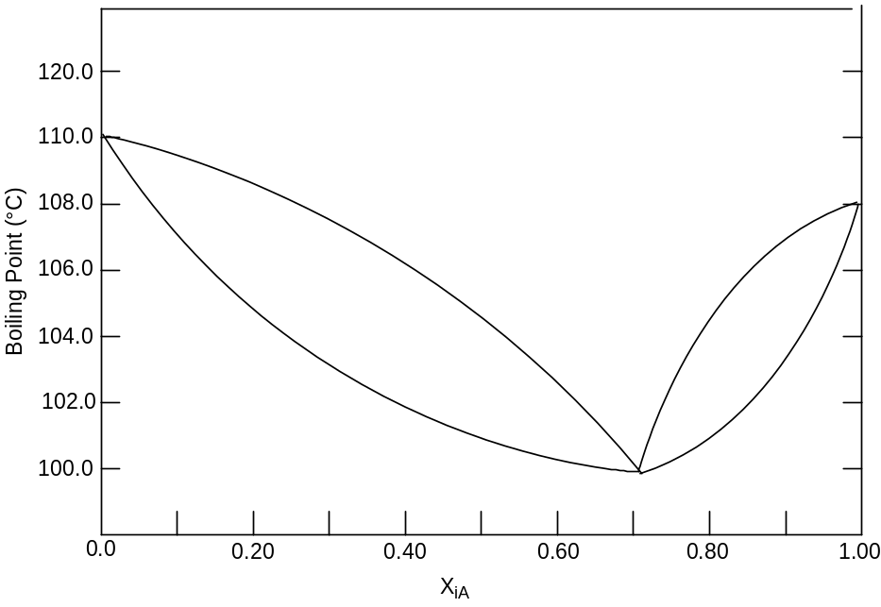

- What is the boiling point of pure A? (2 points)

- What is the composition of the azeotrope? (2 points)

- What is the boiling point of the pot solution when the solution is 20% A? (2 points)

- In the simple distillation of the solution that is 20% A, what is the expected temperature of the initial distillate? (2 points)

- In the fractional distillation of the solution that is 20% A, what is the expected temperature of the initial distillate? (2 points)

- If cooling the solution fails to produce crystals, give two methods for inducing recrystallization and describe how they work. (4 points)

- Predict the direction of each of the following equilibria using the appropriate equilibrium arrows: 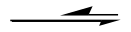and 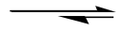 (6 points)
- 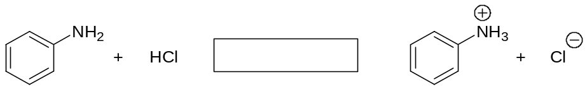
- 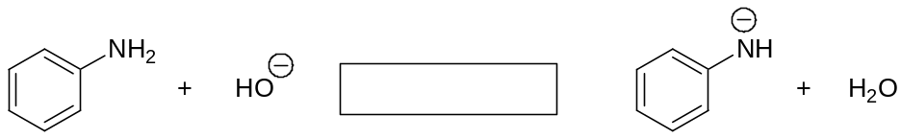
- 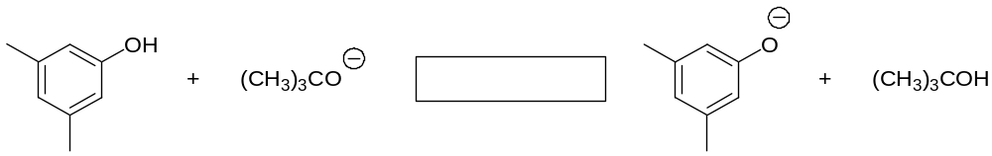

- Select the best technique for the separation of methanol from a non-volatile but soluble impurity. (2 points)
(a) simple distillation (b) gravity filtration
(c) fractional distillation (d) recrystallization

- What percentage of 2,4-dinitrophenol (pK_{a} =4.1) is ionized in a 10% aqueous solution of NaHCO₃ (pH = 8.2). Show work. (3 points)

- What does each letter of the acronym PASS represent in the use of a fire extinguisher
(2 points)
P
A
S
S
- For fractional distillation, HETP may be increased by which of the following? Select all that apply. (2 points)
  - changing the column packing
(b) decreasing the distillation rate
(c) increasing the column length
(d) decreasing the external pressure

- Explain why you should not allow a flask to boil to dryness during a distillation although it may allow you to maximize your yield of the product. (3 points)

- Compound B has a melting point range of 128.2 – 131.4°C. To determine if the compound is trans-cinnamic acid (m.p. 131 – 133°C), a mixed melting point is done using a 50:50 mixture of the compound and pure trans-cinnamic acid. The melting point of the mixture was found to be 129.8 – 132.0°C. What conclusions can be drawn from this experiment?
(3 points)

- Given the solubilities below, which of the following solvents is best for the recrystallization of 1.5 grams of compound A? (3 points)
  - ethanol (b) chloroform (c) methanol (d) water
Solvent | Solubility of Compound A  (grams solute/100 mL soln)
Solvent | @ 10°C | @ b.p.
ethanol | 2.2 | 12
methanol | 0.4 | 8.0
chloroform | 9.6 | 24
water | 0.15 | 1.5

- A solution containing 4.0 g of n-butyric acid in a 100 mL of water was extracted twice with
50-mL portions of benzene. Given the distribution coefficient, K (benzene/water), is 5.0, calculate the amount of n-butyric acid extracted from the water. Show all calculations.
(3 points)

- Discuss two reasons recrystallization typically gives crystals of high purity. (4 points)

- Select the true statements about the melting of a solid. (2 points)
- Melting is a phase change.
- The enthalpy of fusion is typically larger than the enthalpy of vaporization.
- Melting occurs with the vapor pressure of the solid equals that of the liquid.
- The melting point is depressed by insoluble impurities,

- The primary reason for the addition of anhydrous calcium chloride to an organic solvent is
(2 points)
(a) to remove traces of acid (b) to remove color impurities
(c) to remove residual water (d) to remove dissolved salts.

- Select the best approach to separate two immiscible liquid. (2 points)
(a) separatory funnel (b) gravity filtration
(c) rotary evaporation (d) simple distillation

- Define azeotrope. (3 points)

- Which pair of solvents can’t be used for liquid-liquid extraction? (2 points)
(a) methylene chloride and water
(b) diethyl ether & saturated aqueous sodium chloride
(c) acetone and water
(d) hexane and methanol

- For each of the following functional groups, draw the general structure, give the approximate pKa, and draw the conjugate base. The first has been done. (6 points)
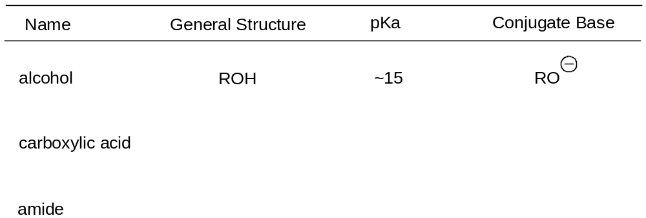

- Which of the following melting point capillaries is packed with the appropriate amount of compound? (2 points)
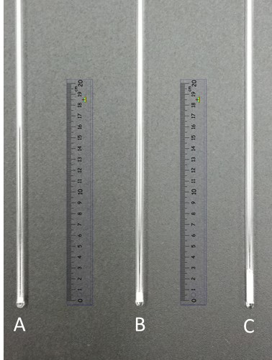

- Which of the following should be immediately used if you spilled a large amount of chemical on yourself? (2 points)
(a) fire extinguisher (b) fire blanket
(c) eye-wash fountain (d) safety shower

- During a recrystallization, the desired compound dissolved but an insoluble impurity remained. Describe the procedure for removing the impurity. (4 points)

